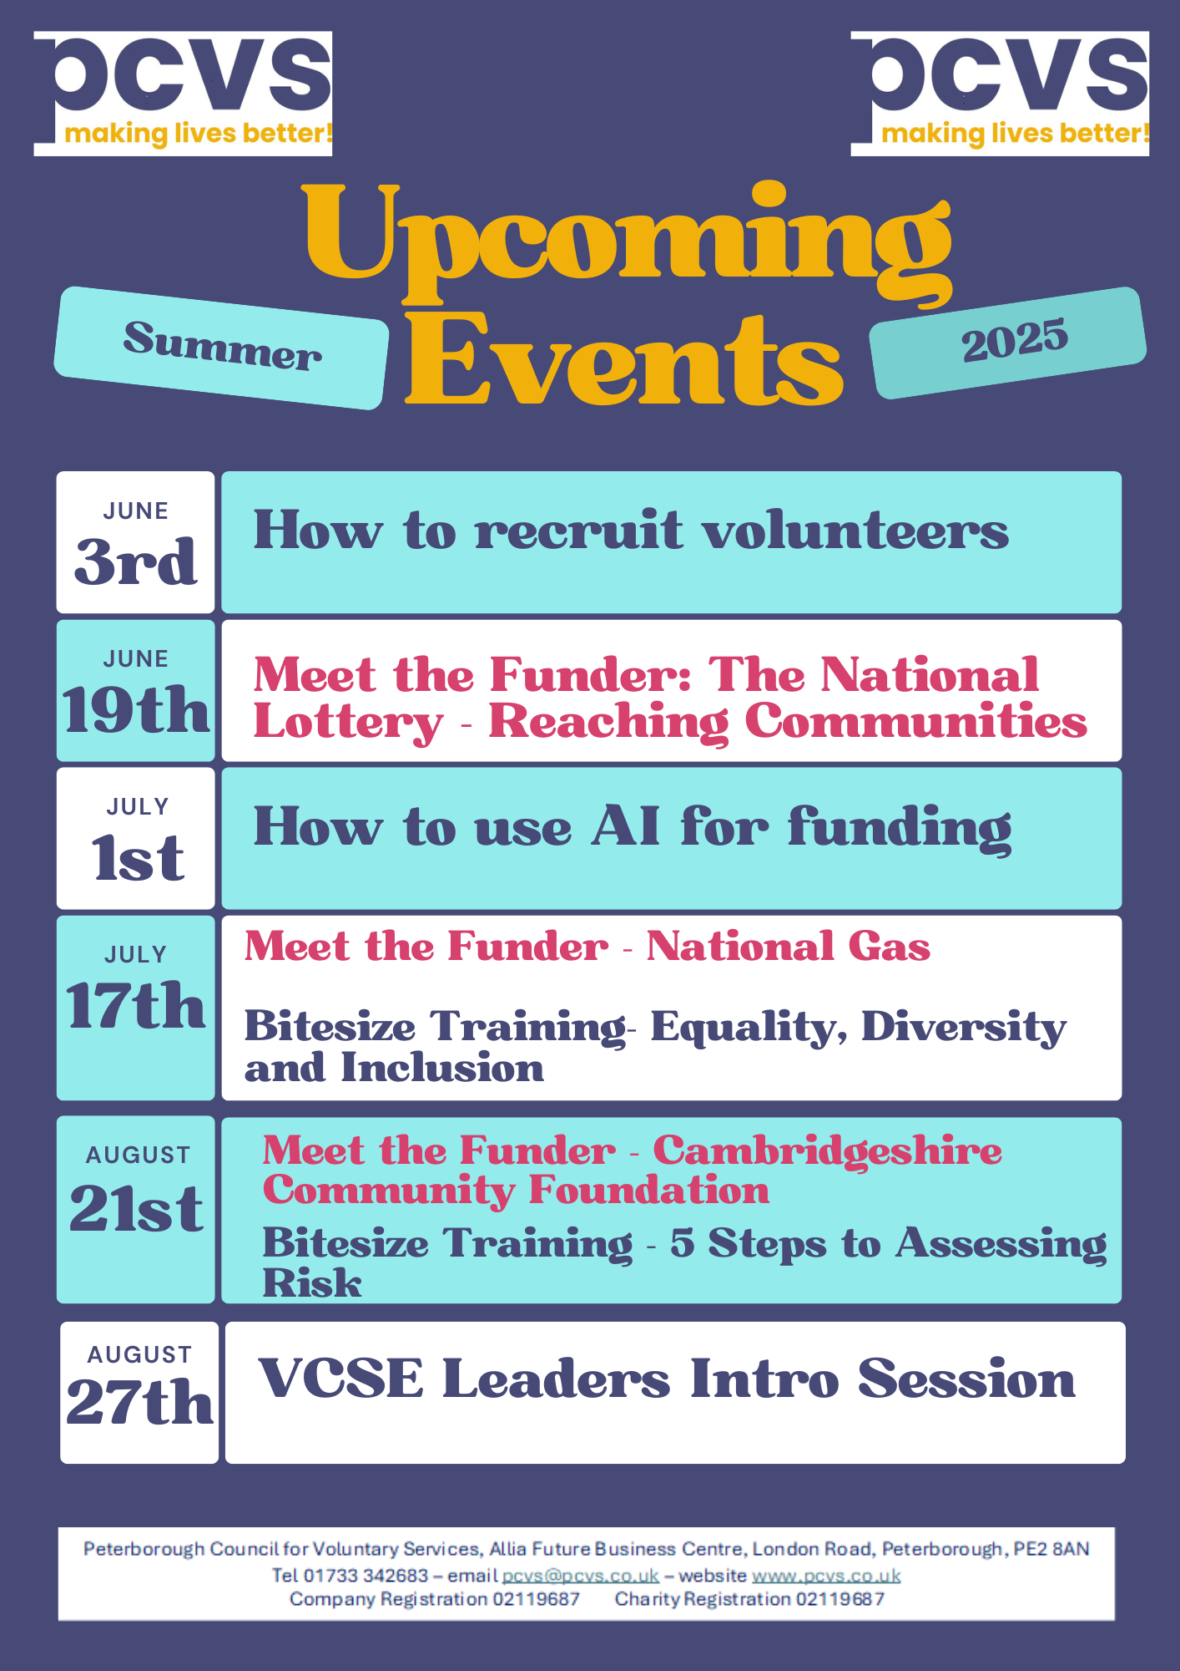

Week Commencing 3 June 2025

I hope you are all well and that you have managed to take some time out to enjoy the lovely summer weather we've seen of late.

We are sending this email to all people and organisations on our current communications list, so please accept our apologies if you receive this twice whilst we cleanse and update our contact lists.

This is a quick news update for you all as there's been lots going on at PCVS and there's also some great opportunities coming up that you might find of interest. All the info can also be seen in our latest June Newsletter and on the PCVS website so do take a further look if anything catches your eye. There're some promotional flyers attached about our **upcoming training and networking events** with further information and how to book. The registration links to the next two events are below:

Peterborough Community Research Champions Celebration and Networking Event Tuesday 17th June 12pm - 2pm - PCVS offices - [click here](https://www.go-vip.co.uk/o/PCVS/forms/4106)

Third Thursday Networking - Lottery Funding 19th June 10am - 12pm [click here](https://www.pcvs.co.uk/events/#pcvsEvents)

We have been busy consulting with existing and potential new PCVS members about our **Membership Offer**. There has been a couple of Membership Engagement Events already held with another planned for 12th June. If you would like to be part of the engagement activity, we will be holding another event in July, this time online to provide an opportunity for those of you who can't make the events in person - further information about this will be shared soon, however if you would like to find out more in advance, please get in touch.

As you may be aware, we have been reviewing our **communications work** and launched a new PCVS website at the end of last year. If you haven't had chance to take a look at the site, please do check it out and let us know if you have any feedback as we're still updating and adding information and resources. [www.pcvs.co.uk](http://www.pcvs.co.uk/) Our members area on the website isn't currently open whilst we consult on our new Membership Offer but watch this space or attend one of our upcoming Membership Engagement events to find out what the site can offer you and your organisation.

If you would like to be removed from our communications list or need to update your organisations details, please do get in touch with us on [communities@pcvs.co.uk](mailto:communities@pcvs.co.uk) and if there is anyone who you feel would benefit from receiving news from PCVS please encourage them to contact us so that they can be added as a contact.

I look forward to hearing and meeting with many of you over the summer and let's hope this lovely weather continues for all your outdoor events and celebrations.