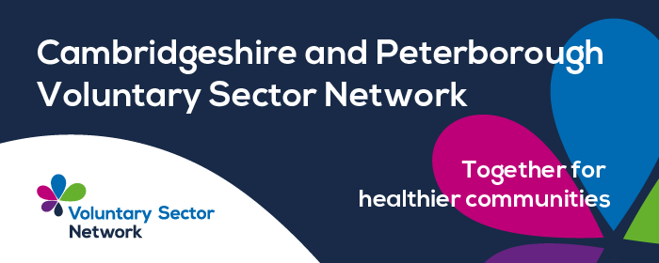

Please find this week's update.

**PCVS Training**

**Tuesday 30th September - 1.30pm - 3pm - Training Tuesday - Theory of Change -** Now more than ever funders want to be clear on the difference you are making with your work, and why you are the right organisation to make it.

A **Theory of Change** is a great tool to do just this.

The National Lottery Community Fund in particular are keen to see more organisations with a really clear Theory of Change; but more than helping you secure funding, this can help you:

* Plan your strategy to achieve your purpose.
* Use the knowledge you hold as an organisation more effectively.
* Make decisions about what services you deliver, and how.
* Find the right funding for your organisation to deliver what you know matters.

To book your place [click here.](https://www.pcvs.co.uk/events/#pcvsEvents)

**Other Training & Events**

**Cambridgeshire Digital Partnership** are hosting a couple of webinars in early October. They are free to register if you are a voluntary organisation in Cambridgeshire.

* Digital Literacy for Youth: Risks & Opportunities -to register [click here.](https://cambridgecvs.org.uk/event_listing/digital-literacy-for-youth-risks-and-opportunities/)
* Culture Connects: Using Culture and the Arts to bridge the digital divide - to register [click here.](https://cambridgecvs.org.uk/event_listing/culture-connects-using-culture-and-the-arts-to-bridge-the-digital-divide/)

**Safer off the Streets -** Join us for a free, half-day in-person STOP Suicide workshop with Cambridgeshire, Peterborough and South Lincolnshire Mind.

Learning outcomes for the workshop

Identify persons at risk of suicide

Know about communities at particular risk of suicide

Finding connection to life

Talk openly about suicide and help a person at risk to stay safe

Look after your own wellbeing

Be aware of crisis and support services

[Click here to register your interest](https://forms.office.com/pages/responsepage.aspx?id=yHpqHocApEuV6WI1iWk5jz9Qeiva8RdFkBn6qsgoNh5UQVdFV0FGSUtPQUdIODk3MVRNWlE3MUY2TS4u&route=shorturl) - we will contact you ASAP to confirm your space.

📅 Date & Time: Monday 13th October - prompt 1.30pm start. Session finishes at 4.30pm

📍 Venue: Peterborough Salvation Army Citadel, 1203 Bourges Boulevard, Peterborough, PE1 2AU

🚗 Parking: Free parking is available behind the Citadel.

⚠️ Spaces are limited to 18 delegates. Please book quickly to secure your place. If you are unable to attend after booking, let us know as soon as possible so your space can be offered to someone else.

**Voluntary Sector Network Updates**

Please below the link to the September 2025 Newsletter, which includes a Health Inequalities Information Statement Data Pack:    <https://supportcambridgeshire.org.uk/cambridgeshire-and-peterborough-voluntary-sector-network-update-bulletin-september-2025/>