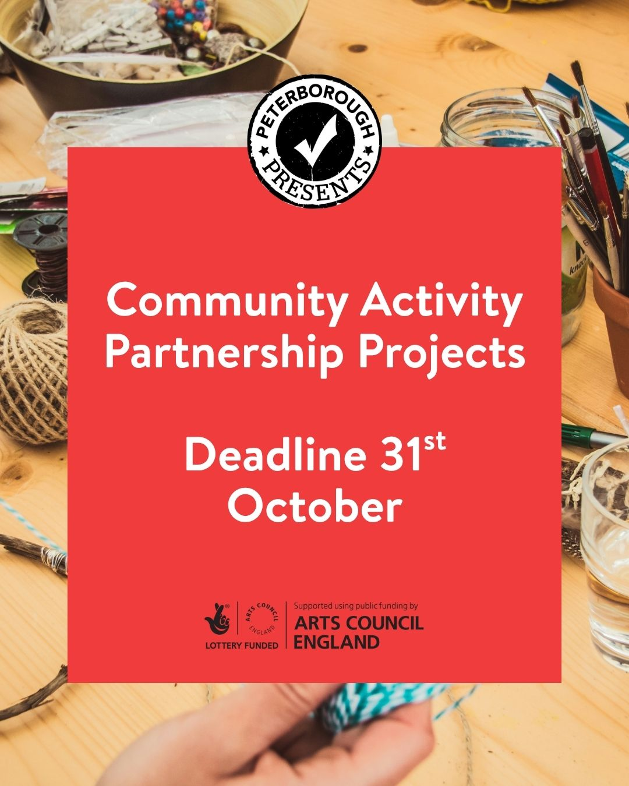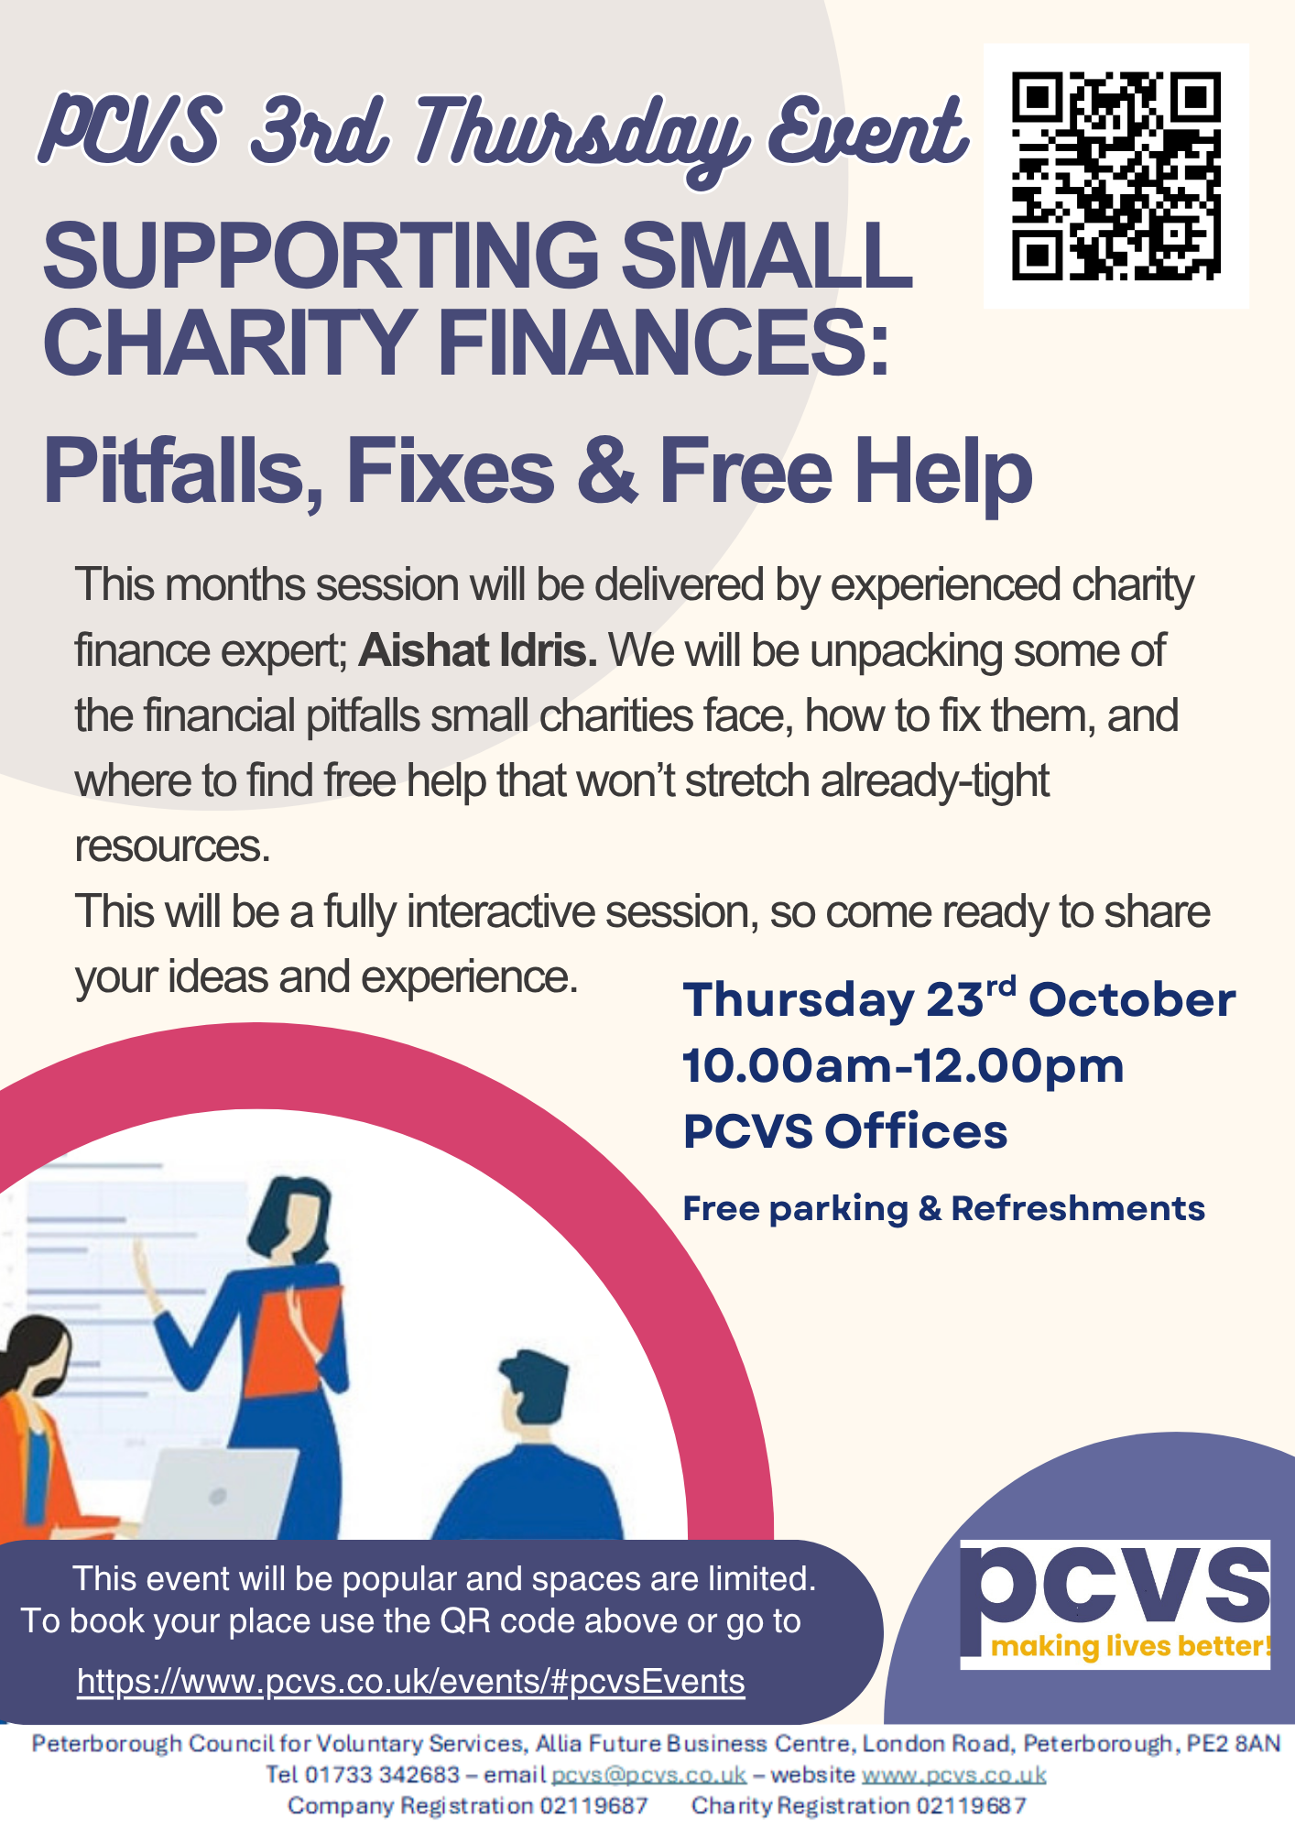

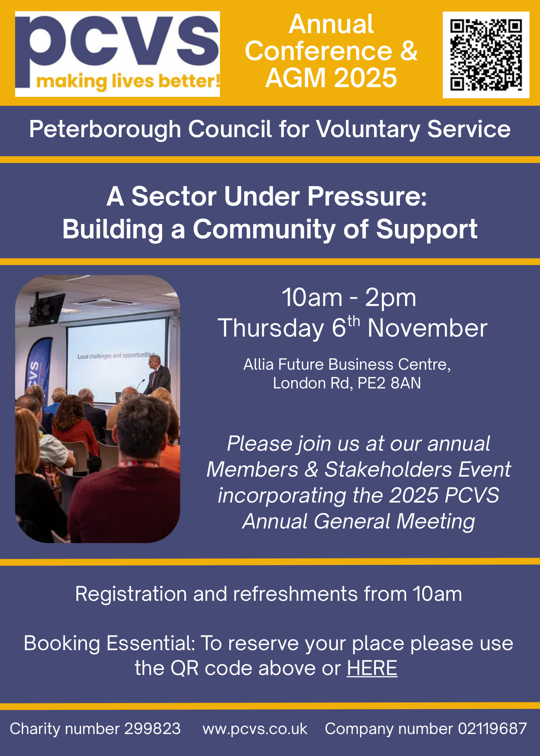

**Weekly Update – week commencing 13th October 2025**

**Training**

Join us for our next third Thursday networking event on **23rd October 10am - 12pm.** Actually, this is the fourth Thursday – but just as good!

This event always features lots of time for networking! In addition, there’s often a slot on funding and fundraising, plus a short training item, or a full training session.  
This month's session will be delivered by **Aishat Idris**, who will be giving tips, advice and guidance in managing your charity finances. This invaluable session will leave you feeling more confident in this area. With the usual networking opportunities this promises to be a great session. To register [click here.](https://www.pcvs.co.uk/events/#pcvsEvents)

**PCVS Jobs**

PCS are delighted to announce we are recruiting a full-time role into our Communities team. **The Senior Development Officer role** (12-month fixed term contract - salary £32,708) will strengthen and deliver all aspects of our infrastructure support to our voluntary and community here in Peterborough.  
  
This full-time role will ensure that there is provision of expert guidance, capacity-building support, and strategic development, focusing on funding, partnership building and supporting excellent governance. It is a crucial and varied role supporting the heart of our communities. It will also provide support with financial planning and training in a bespoke way. It is a crucial role that PCVS fulfils to ensure that our VCSE community is thriving, and our community voice is heard.

This is in addition to the three other roles in the communities team that we recently advertised:

Operations Manager - Health and Communities - Full Time - £37,518 - 24 months fixed term.  
Senior Development Officer – Health Inequalities - Part Time - £32,708 - pro rata 30 hours - 12 months fixed term.  
Development Officer - 12 months fixed term - Part Time - £25,974 - pro rata 18.5 hours.  
  
If these roles sound like something you are interested in applying for, we would ask any prospective candidates to email [**recruitment@pcvs.co.uk**](mailto:recruitment@pcvs.co.uk) to get the full Job Description and Person Specification.  
  
To apply for the role, we ask candidates to email their CV and a one page covering statement as to why they believe they are the right person for the job. Closing date is 22 October for the previously advertised roles and 5th November at 9am for this latest role.  
  
You can find out more about all four roles [here.](https://www.pcvs.co.uk/about-us/jobs/)

**Other Jobs**

**Gladstone Connect - Welfare Officer -** Salary £27,300 pa pro rata.

An exciting opportunity has arisen for an enthusiastic individual to join Gladstone Connect as a Welfare and Benefits Advisor. At Gladstone Connect we are passionate about developing services which meet the needs of local residents. The successful post holder will possess a deep understanding of the benefits system and be experienced in delivering specialist welfare rights advice and casework to a very high standard.

The post holder will have the confidence and initiative to work independently. They must be calm and competent under pressure, able to manage a large caseload. The post holder will interact daily with people (and their families) from diverse backgrounds living in Millfield. The welfare officer will be based at the Allama Iqbal centre.

Gladstone Connect is keen to welcome applicants with the skills and motivation to join a busy and energetic team. The ideal candidate will be fluent in English, Punjabi and Urdu.

This opportunity is a part time post of 10 hours per week for a fixed term period until September 2026.

To apply please send a covering letter and CV to centre manager, Helen Walkinshaw, no later than 23rd October 2025 [manager@gladstoneconnect.org](mailto:manager@gladstoneconnect.org). Interviews will be held w/c 27th October. For further information please contact Helen Walkinshaw, centre manager on 07919 167239.

**Family Action**

Job title: **Community Development Lead**

Service: Woodfield Park Community Project

Salary: Grade 2 Points 20 –23: £28,884 - £31,698 FTE per annum

Hours: flexible hours to be agreed 28-37 hours per week

Location: Woodfield Park - Welland

Responsible to: Service Manager

Summary of job:

Family Action is seeking a passionate and experienced Community Development Lead to drive our Lottery-funded initiative aimed at transforming Woodfield Park Community Centre into a vibrant, inclusive, and welcoming community hub for all.

You will be responsible for leading community engagement including the development and delivery of community-led activities and volunteering opportunities. Your work will focus on fostering social change, enhancing mental and physical wellbeing, building resilience, and growing local community connections.

You will lead on partnership building, stakeholder engagement, and the co-creation of services with local residents, ensuring that the centre reflects the needs and aspirations of the community it serves. This is a unique opportunity to shape a lasting legacy and make meaningful impact in the lives of individuals and families in Welland.

Closing Date: 20th October 2025 at 23:59 - see attached flyers for more information and how to apply.

**PCVS 2025 Annual Conference and AGM** is now open for booking.

**'A Sector Under Pressure: Building a Community of Support'**

**Thursday 6th November**

**10am - 2pm**

**Allia Future Business Centre, London Rd, PE2 8AN**

Please see the invitation attached for more details and how to book your place or use this [link](https://www.go-vip.co.uk/o/PCVS/forms/4442) to book. If you have any problems, please copy and paste this address into your favourite browser <https://www.go-vip.co.uk/o/PCVS/forms/4442>.

We hope that you will be able to join us for this important event where we will be launching our new Membership Offer, discussing the pressures that our sector is facing and exploring how we can build effective support for all our communities.

**Peterborough Presents - Community Activity Partnership Projects**

Want to try a new creative project in Peterborough?

Peterborough Presents are offering up to £2,000 and partnership support for creative activities.

The project must take place between November 2025 and March 2026 and engage at least one of our target audiences, such as global majority, DDN, young adults, men, or residents in specific areas of the city.

You can apply as a community group, small not-for-profit organization, or independent creative (partnering with a group). The deadline to submit your proposal is October 31, 2025.

To find out more and how to apply [click here.](https://peterboroughpresents.org/community-activity-partnership-projects/)

If you would like anything promoting, please drop me a line.